**Project Design Phase-II**

**Solution Requirements (Functional & Non-functional)**

|  |  |
| --- | --- |
| Date | 26-05-2025 |
| Team ID | LTVIP2025TMID55695 |
| Project Name | DocSpot: Seamless Appointment Booking for Health |
| Maximum Marks | 4 Marks |

**Functional Requirements:**

Following are the functional requirements of the proposed solution.

**Functional Requirements – Music Streaming App**

|  |  |  |
| --- | --- | --- |
| **FR No.** | **Functional Requirement (Epic)** | **Sub Requirement (Story / Sub-Task)** |
| **FR-1** | User Authentication | Sign up, Login, Password Reset   |  | | --- | |  | |
|  |  | |  | | --- | |  |  |  | | --- | | OAuth login using Google / GitHub | |
| **FR-2** | **Appointment Booking** | Search doctors by specialty, location, and availability |
|  |  | Book, reschedule, and cancel appointments |
| **FR-3** | **Calendar & Schedule Management** | Freelancers apply to jobs |
|  |  | View upcoming and past appointments |
| **FR-4** | **Notifications & Reminders** | Automated SMS/email reminders for upcoming appointments |

**Non-functional Requirements:**

Following are the non-functional requirements of the proposed solution.

|  |  |  |
| --- | --- | --- |
| **NFR No.** | **Non-Functional Requirement** | **Description** |
| **NFR-1** | **Usability** | |  | | --- | | The platform should provide a simple, clean UI for all users, including patients and healthcare providers. | |
| **NFR-2** | **Security** | |  | | --- | | All patient and appointment data must be encrypted. Implement role-based access and secure authentication | |
| **NFR-3** | **Reliability** | |  |  | | --- | --- | | |  | | --- | | Appointment booking, notifications, and telehealth services must be available and dependable at all times. | | |
| **NFR-4** | **Performance** | Pages and booking actions should load within 2 seconds; reminders and notifications should be timely. |
| **NFR-5** | **Availability** | |  | | --- | | The system should ensure 99.9% uptime with minimal downtime. | |
| **NFR-6** | **Scalability** | |  | | --- | | Support a growing number of users, providers, and concurrent bookings without degradation. | |

**Landing page :**

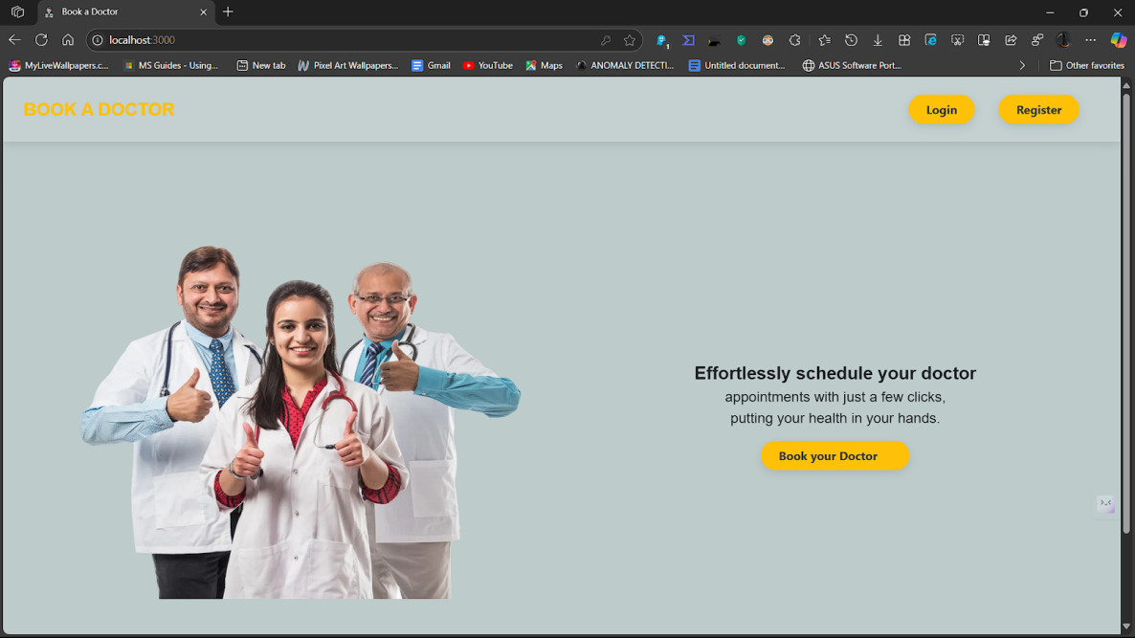

**Register page:**

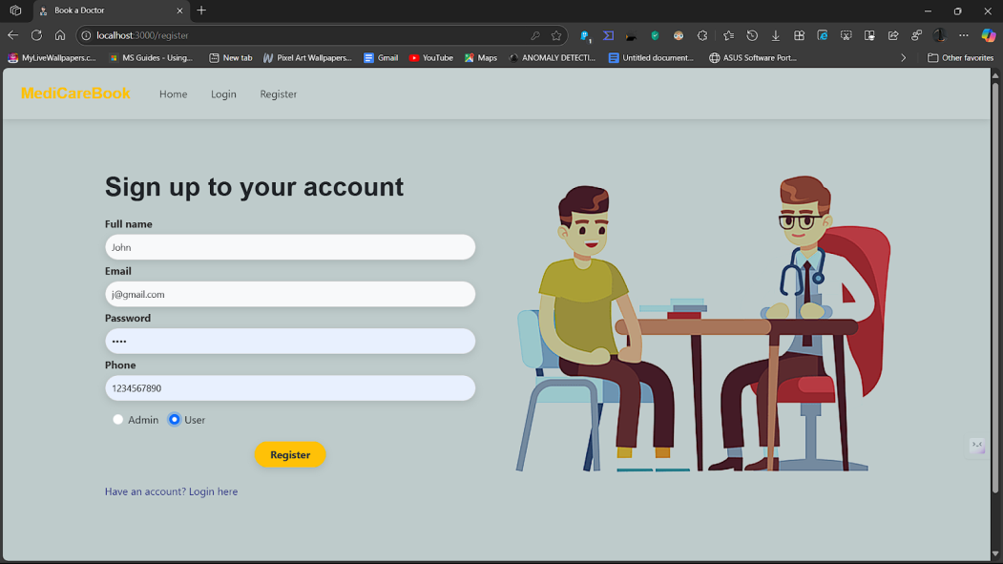

**Login page:**

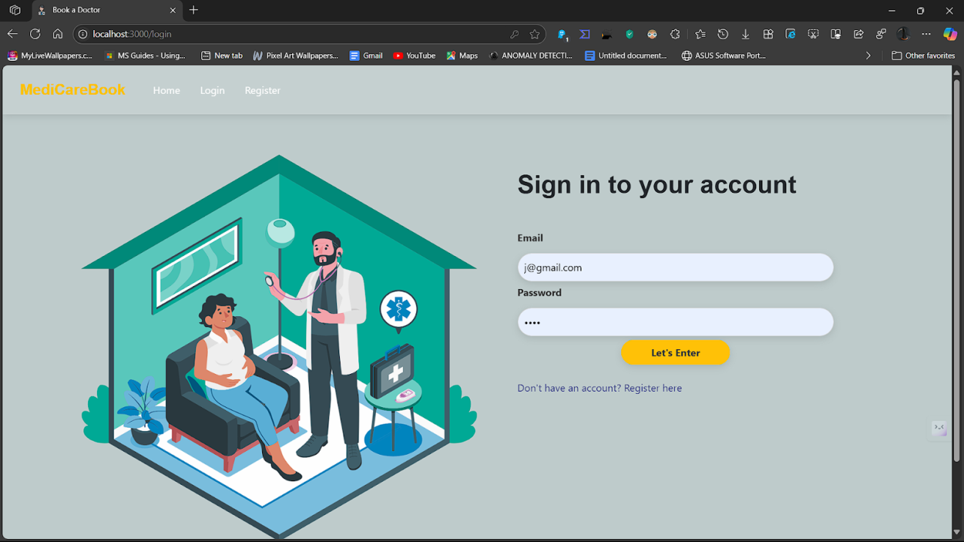

**Admin Dashboard:**

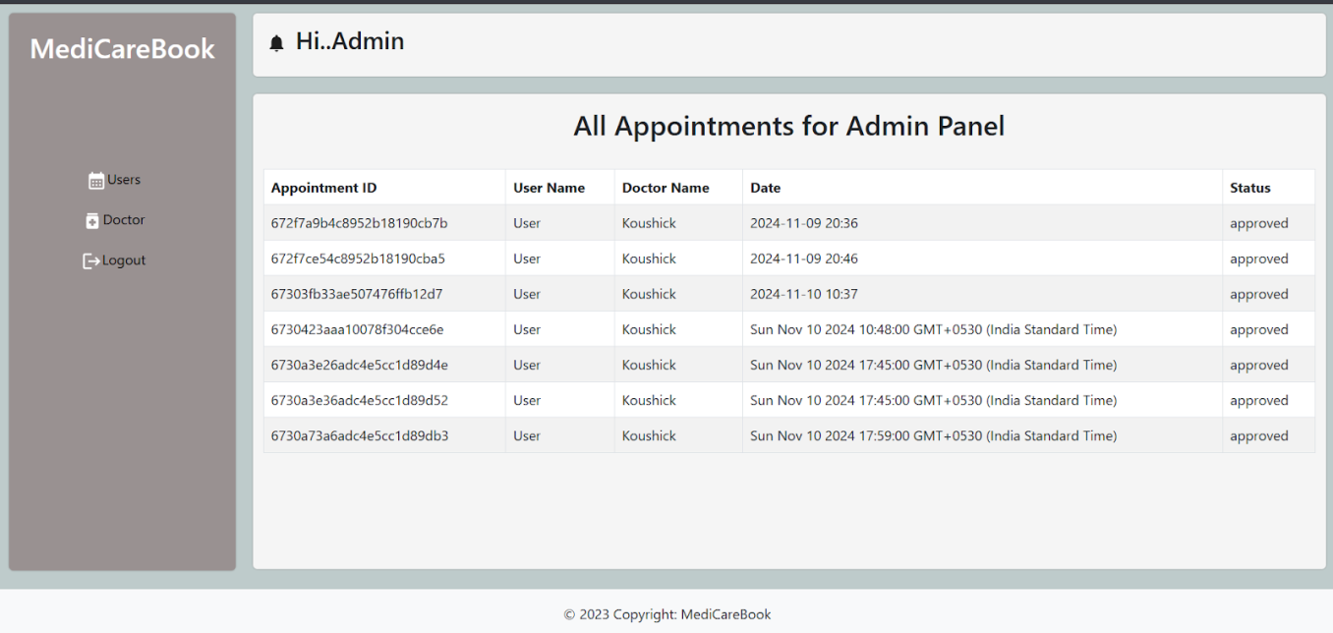

**Doctor dashboard:**

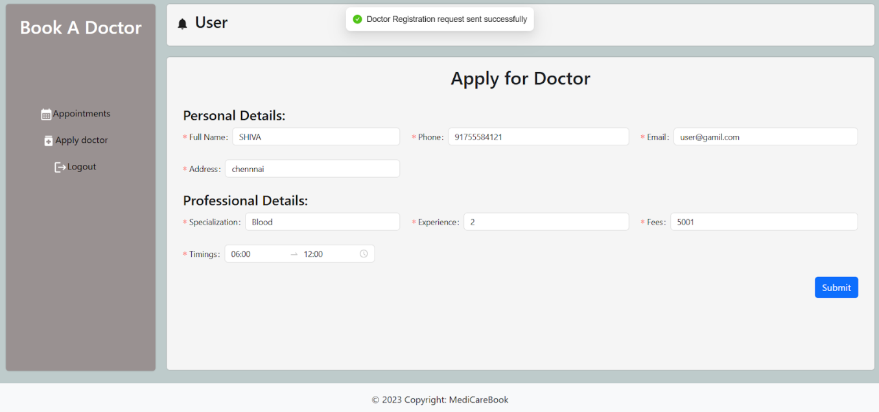

**Admin approve doctor:**

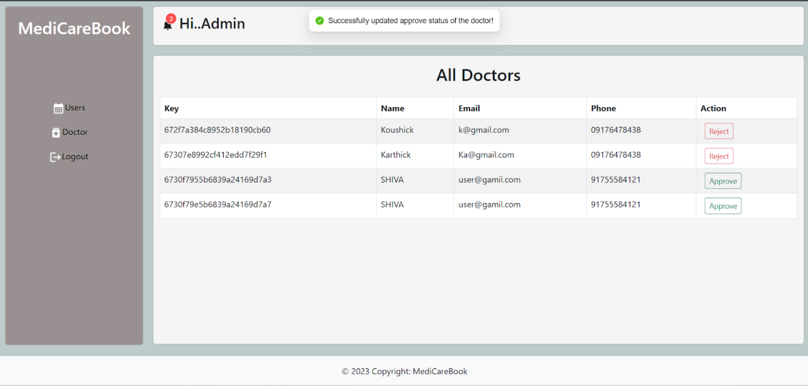

**BOOK DOCTOR :**

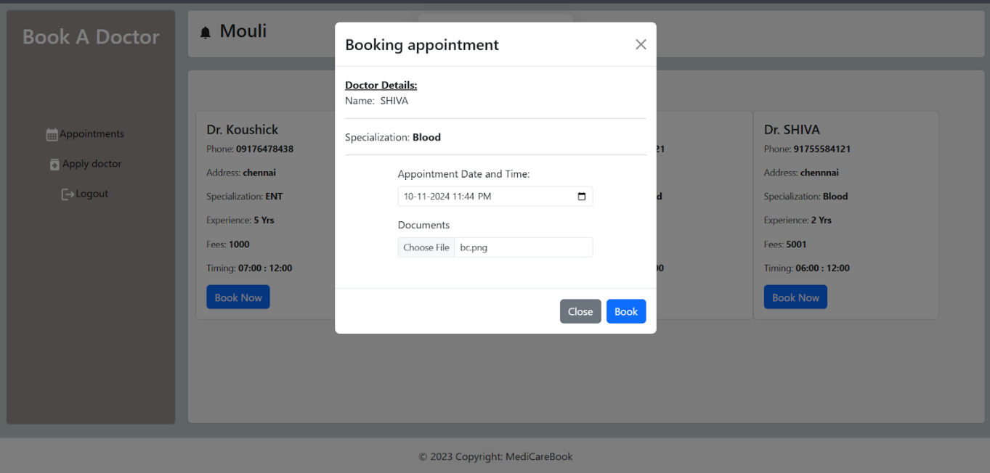

**ALL HISTORY :**

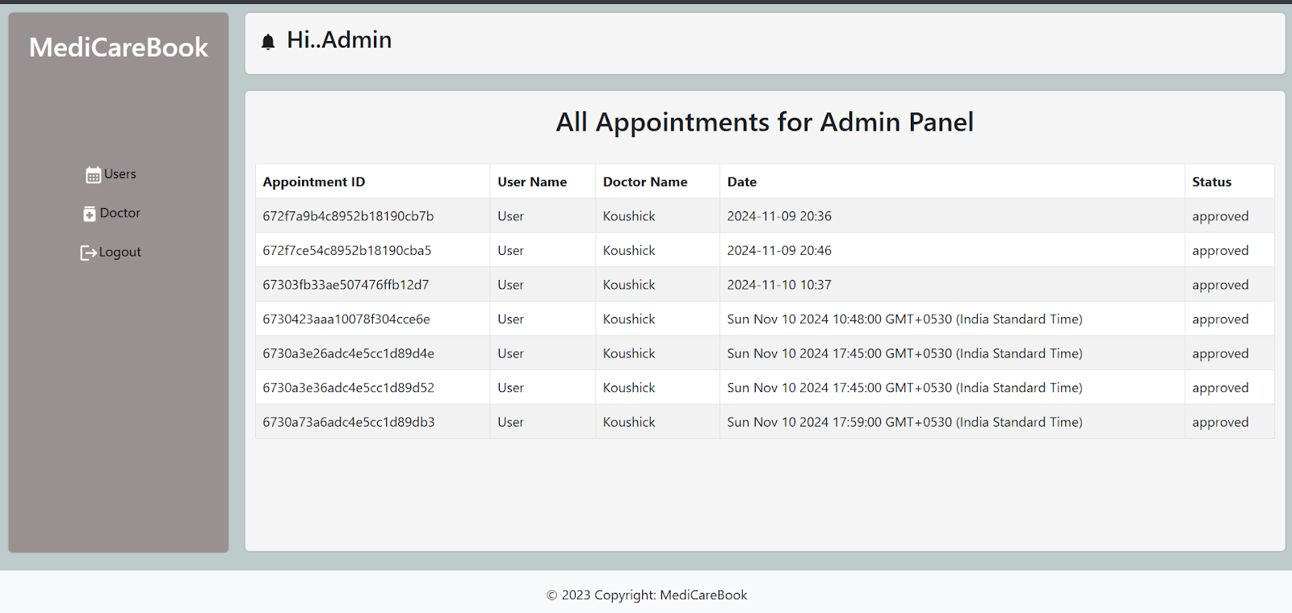

**User dashboard:**

